Crievewood United Methodist Child Care SUMMER FUN

3 Star Center Serving School Age Children K-4th grade
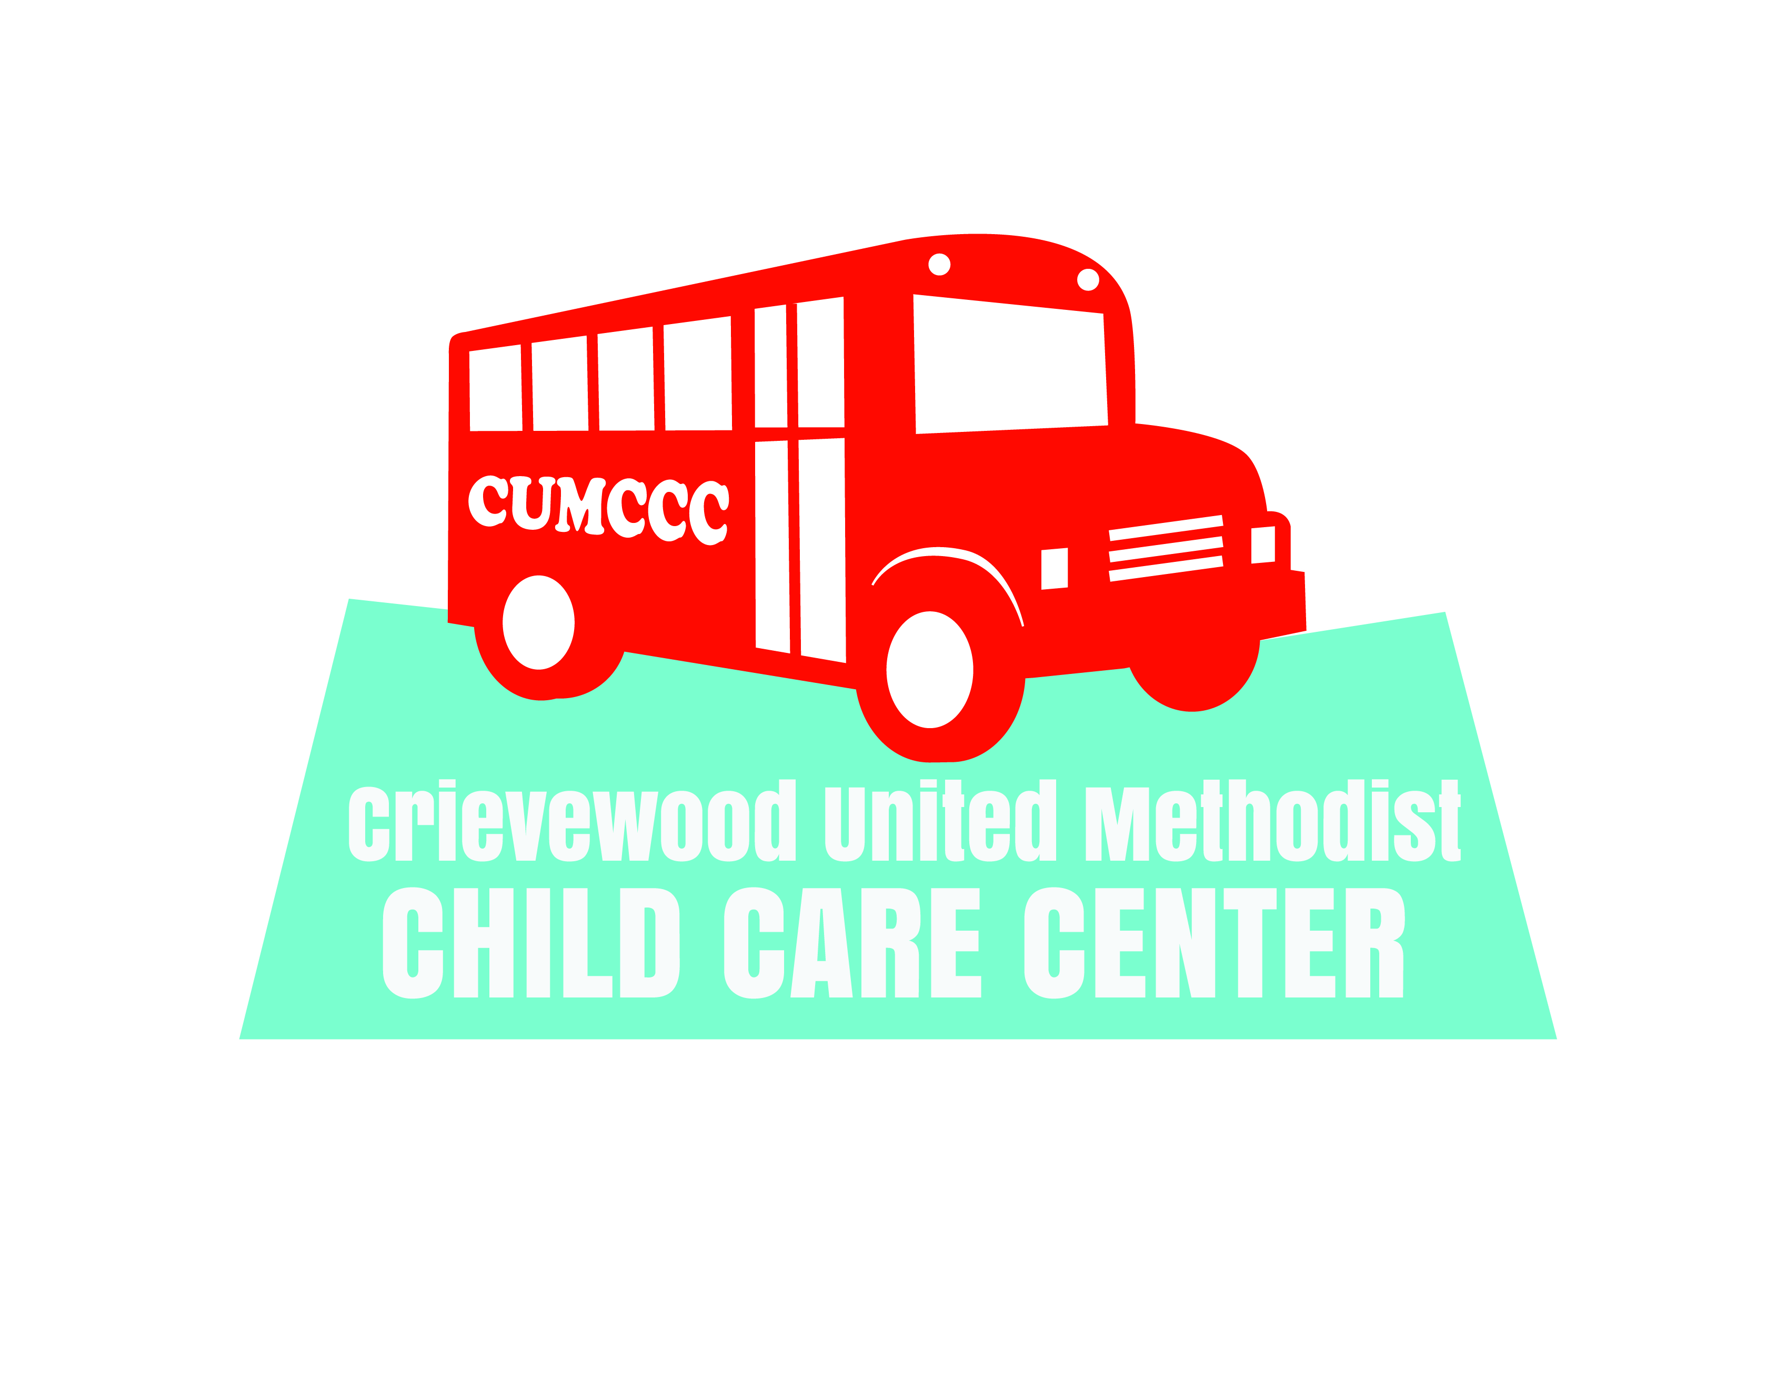
Join the BIG RED BUS gang for a SUMMER of FUN!
451 Hogan Road
Nashville, TN 37220
Phone: 615-834-7255
*Sharon Ferrell, Director of Operations: director@crievewoodumc.org
*Dee Ramirez, Program Director: DeeRamirez@crievewoodumc.org

Summer Fun Registration time is NOW.
The 2019 summer program runs May 28th to July 31st.
It is time to secure your spot[s] for summer. At this time we are only registering children that want the full summer program. Please fill out the registration form below. Return the form, along with your registration and activity/ supply fee, to the child care office. Drop it by or mail it to us. Available spots are limited by age group, so don’t delay. Children are registered on a first come first serve basis.
- Registration Fee: $25.00 [non-refundable]
- Supply, Activities, Field Trip Fee: $150.00 [due at time of registration]
- Weekly Rate: 1st child $125.00
2nd child $115.00
- Weekly fees are due one week in advance

Needed Information

Child’s Name: ________________________________________________
Date of Birth: _________________________________________________
Grade just completed: ____________________________________________
Gender: ________________________________________________
Mother’s Name:_________________________________________________
Phone #____________[home]________________[cell]______________[work]
Email address:___________________________________________________
Father’s Name___________________________________________________
Phone #____________[home]________________[cell]______________[work]
Email address:_________________________________________________

What Size T-Shirt does your child wear: {please circle one}
Youth Size X-Small Small Medium Large X-Large Adult Size Small Medium Large X-L

Other Important Information
Hours of Operation: 6:30am to 6:00pm
Light Breakfast served: 7:00 – 8:00 Breakfast is provided
Lunch served: 11:00 am
Milk will be furnished. Children will need to bring a lunch from home each day.
Afternoon Snack: 2:00 Pm Snack is provided
We have been busy planning our Summer Fun Program for your child.
- Swimming each week
- The Ice Cream Truck
- Field trips every week
- One week of VBS

